Task 3
Title:
Protein Structure Prediction of Hemoglobin Subunit Beta Using AlphaFold DB
By: Anshara Maheen

1. Introduction
Protein structure prediction is a key area in bioinformatics that helps in understanding protein function, stability, and molecular interactions. In this task, the 3D structure of hemoglobin subunit beta was examined using AlphaFold DB and visualized with PyMOL software.

2. Protein Information
- Protein Name: Hemoglobin subunit beta
- Organism: Homo sapiens
- UniProt ID: P68871
- Sequence Length: 147 amino acids
Hemoglobin subunit beta is a globin protein responsible for oxygen transport in human blood.
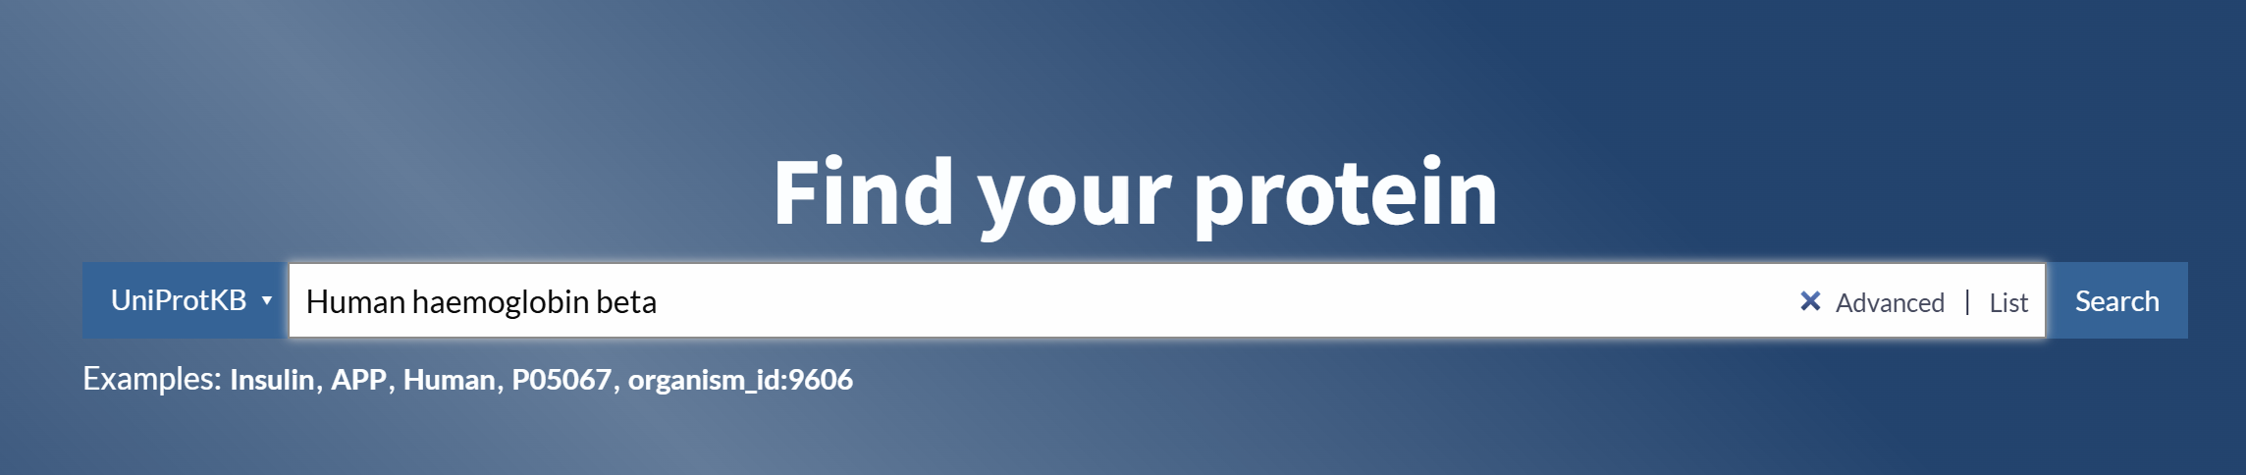
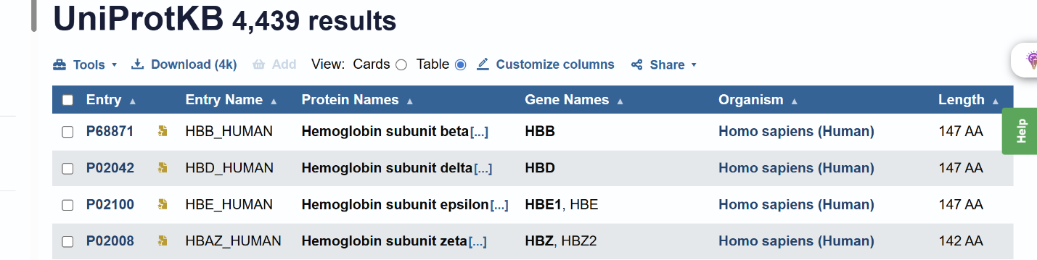

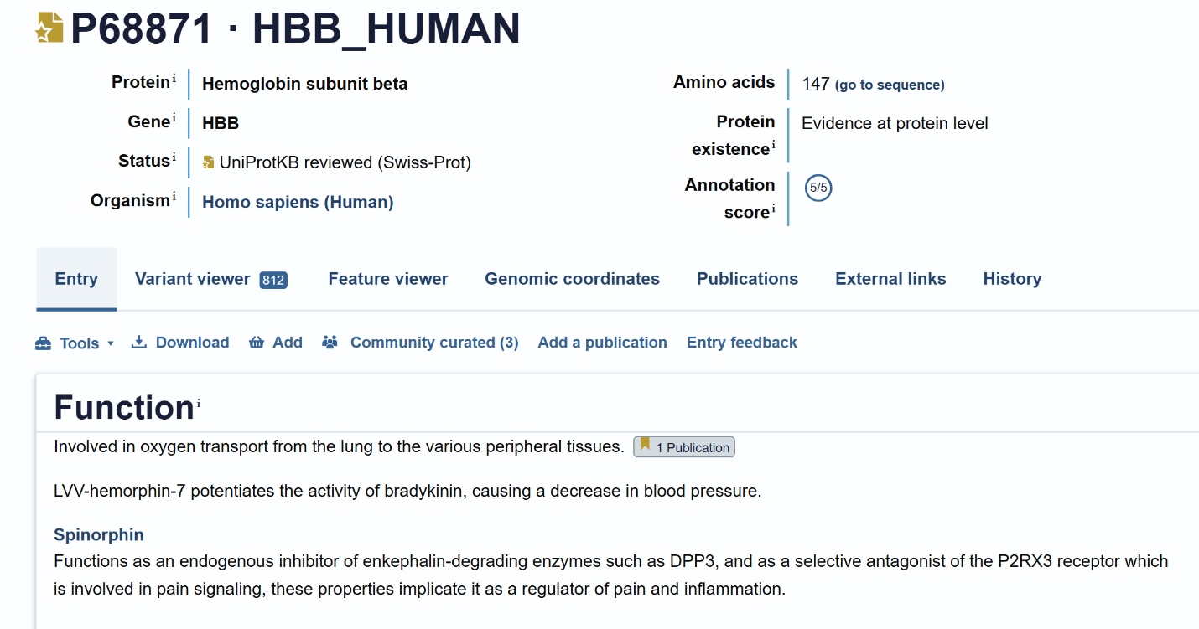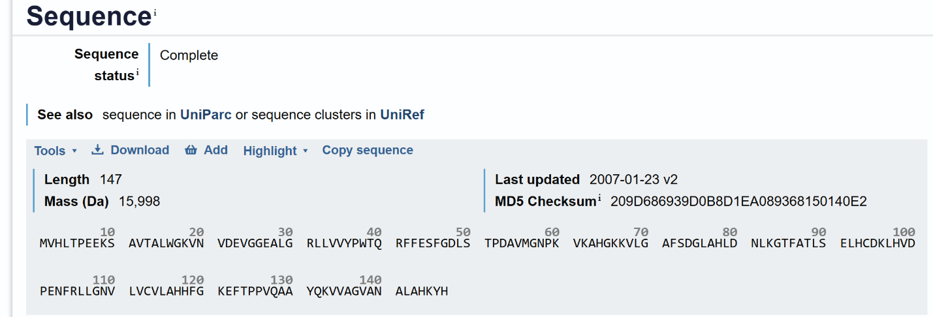

FASTA Sequence
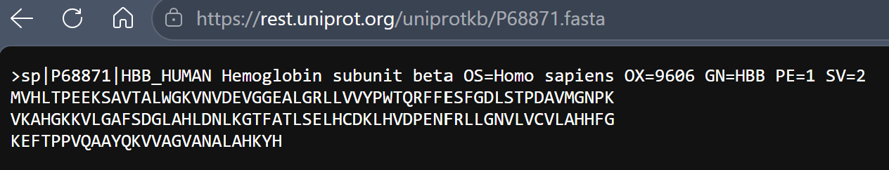

  - Structure Prediction Tool
The three-dimensional structure of the hemoglobin beta subunit was retrieved from the AlphaFold database. AlphaFold is an AI-driven system designed to predict protein structures with high accuracy. The predicted model was downloaded in PDB format for further visualization and analysis.
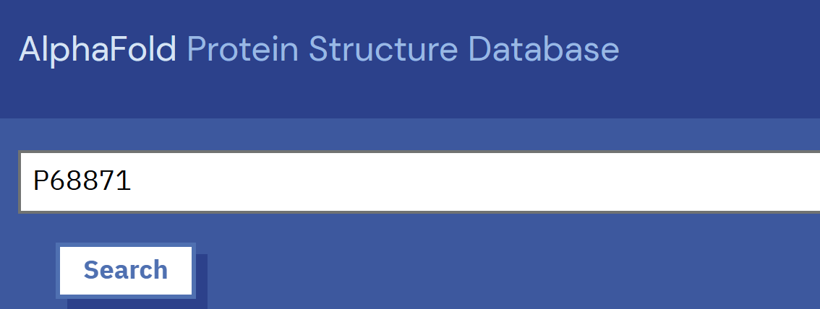
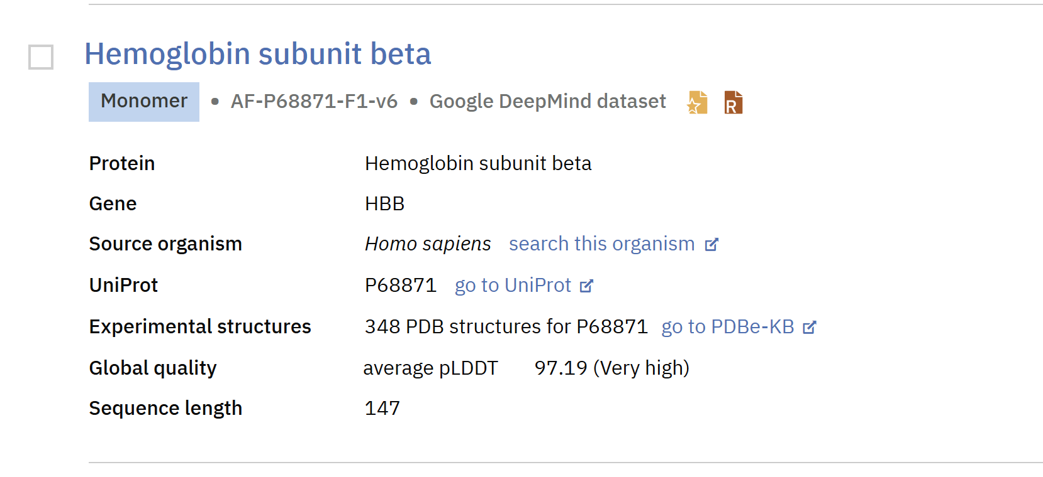
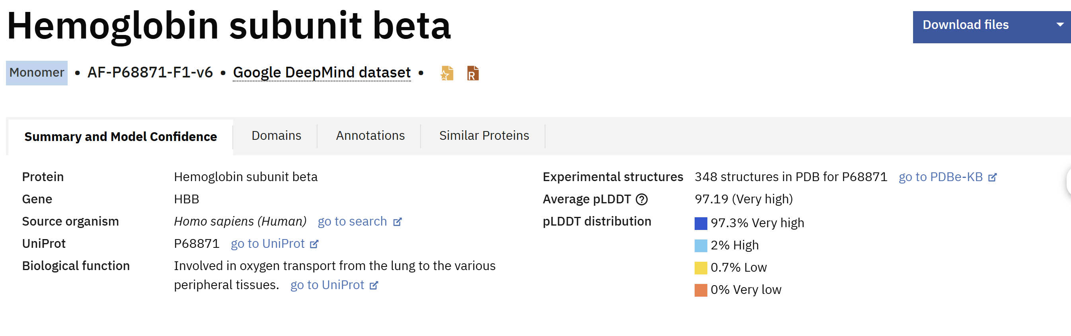
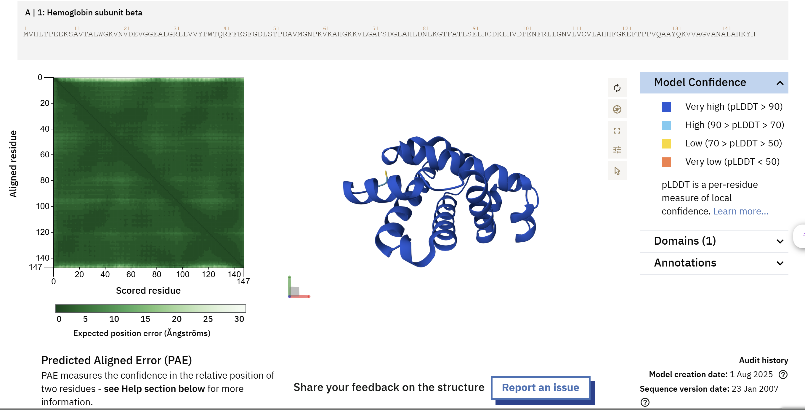
  - Structural Features
The predicted structure exhibited a compact globin fold predominantly made up of alpha-helical segments. The majority of the protein regions were shown in dark blue, reflecting very high confidence levels (pLDDT > 90). The structure displayed well-organized folding patterns that are essential for oxygen transport and overall protein stability.
The Predicted Aligned Error (PAE) plot further indicated high confidence in the positioning of residues across most parts of the protein.
  - Structure Visualization
The predicted protein structure was visualized using the AlphaFold 3D viewer. A cartoon representation was applied to examine the overall folding pattern and the arrangement of alpha-helical regions within the protein.
  - Interpretation
The structural analysis suggests that the hemoglobin beta subunit maintains a highly conserved globin fold that is crucial for oxygen binding and transport. The presence of stable alpha-helical regions highlights the evolutionary conservation of globin proteins across different species.

Conclusion
Protein structure prediction using the AlphaFold database effectively revealed the three-dimensional organization of the hemoglobin beta subunit. Structural visualization enabled the examination of folding patterns, confidence levels, and key structural features. This work highlights the value of bioinformatics tools in understanding protein structure and function.
Overall, the completed tasks demonstrate the application of bioinformatics tools for sequence analysis, structural prediction, and evolutionary interpretation of proteins.

References
[1] European Bioinformatics Institute (EMBL-EBI) (n.d.) AlphaFold Protein Structure Database. Available at: https://alphafold.ebi.ac.uk (Accessed: 14 May 2026).
[2] Jumper, J. et al. (2021) ‘Highly accurate protein structure prediction with AlphaFold’, Nature, 596(7873), pp. 583–589. doi:10.1038/s41586-021-03819-2.
[3] Schrödinger, LLC (n.d.) PyMOL Molecular Graphics System. Available at: https://pymol.org (Accessed: 14 May 2026).
[4] Varadi, M. et al. (2022) ‘AlphaFold Protein Structure Database: massively expanding the structural coverage of protein-sequence space’, Nucleic Acids Research, 50(D1), pp. D439–D444. doi:10.1093/nar/gkab1061.

